- Buyer will Open up the Session Enquiry in Process
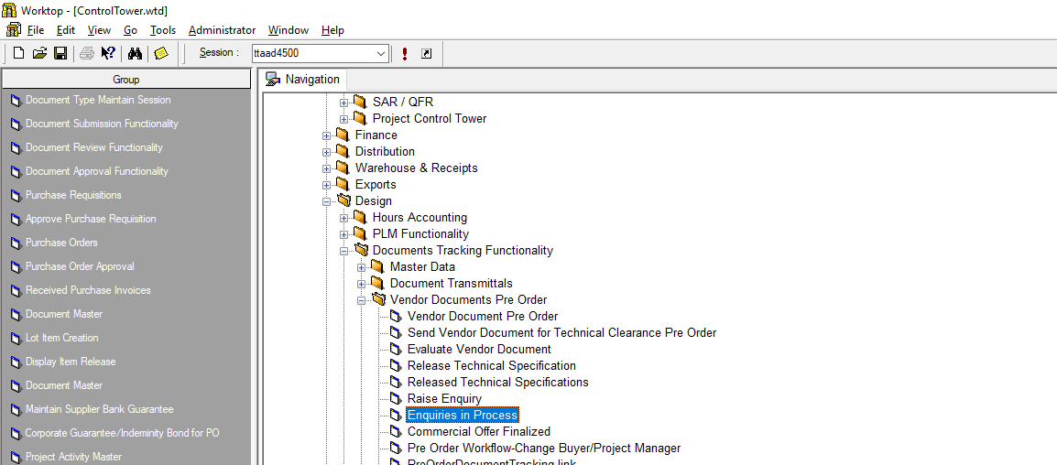
Select This
Session

- Select View Enquiry in the screen that opens up.
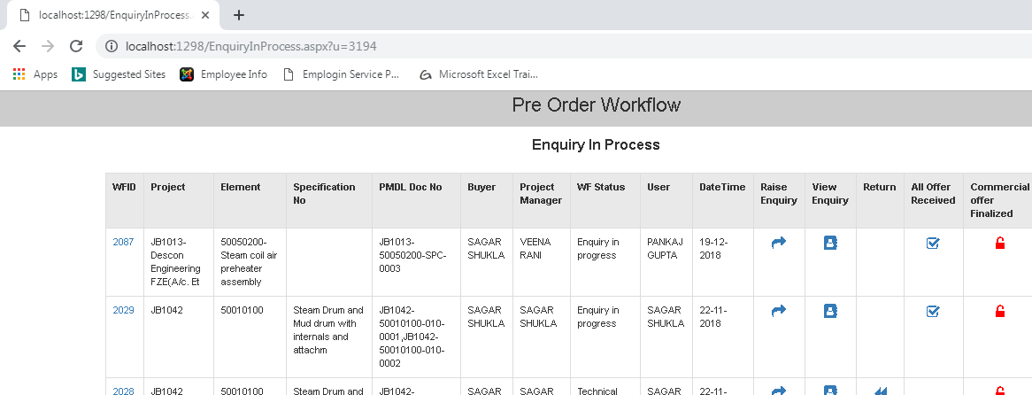
Select View Enquiry
- Click on WFID against that Enquiry.
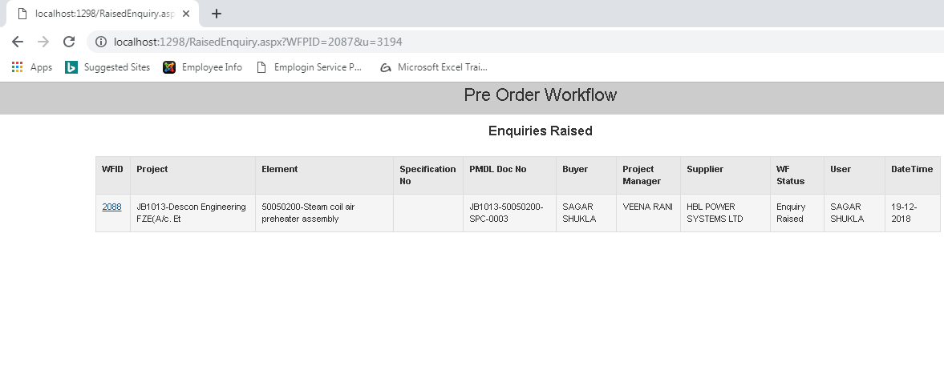
Select WFID

- In the screen that opens up click on Notes.
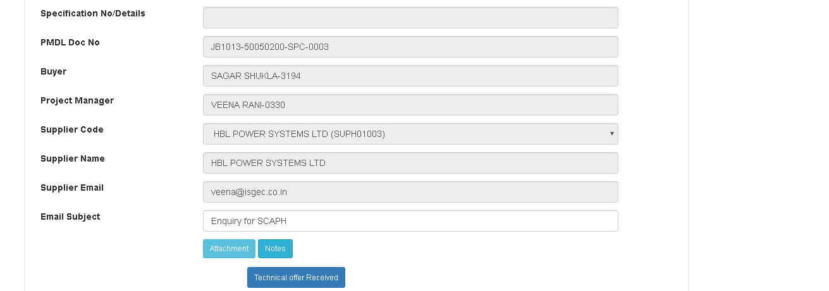
Select Notes
- Click on Enquiry from Vendor.
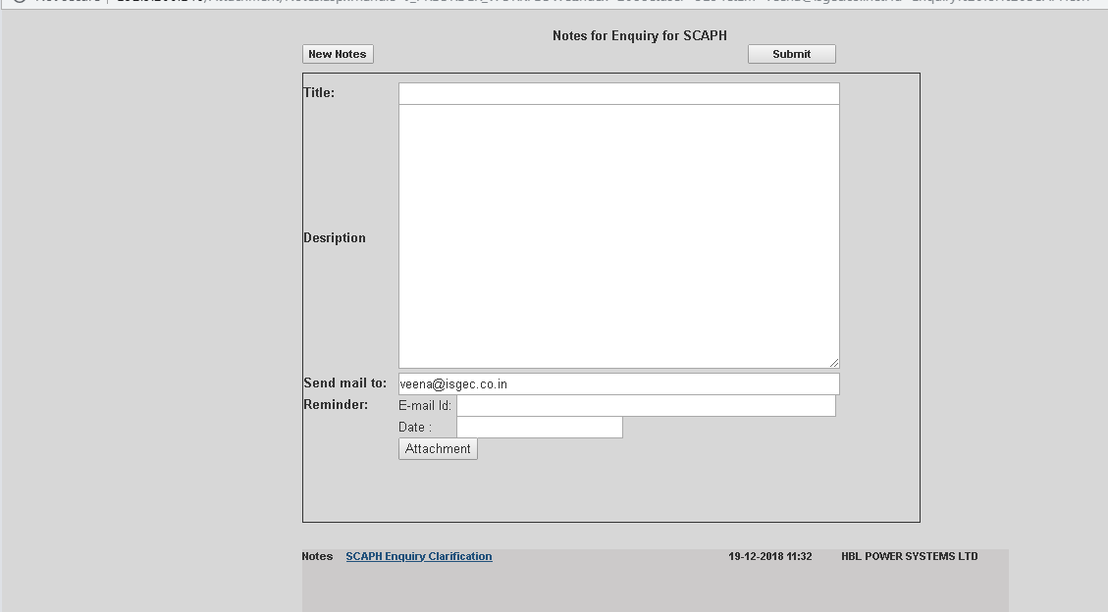
Click On Notes send by Vendor

- Click OK In the screen that opens up then download any attachments (if applicable)
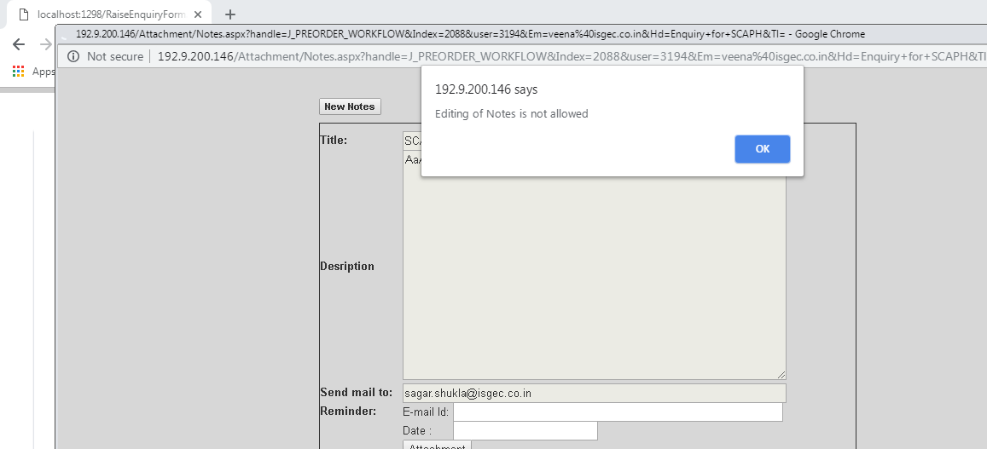
Click OK

- If the Buyer wishes to revert to supplier , the click on Notes as shown.
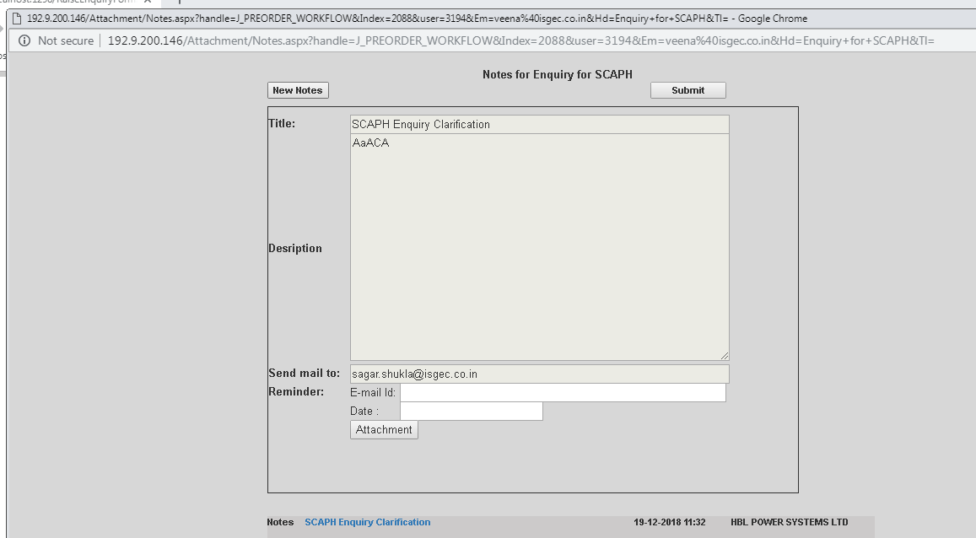
Click on Notes

- Fill Up the Details in the Screen that Opens up and Submit the details.
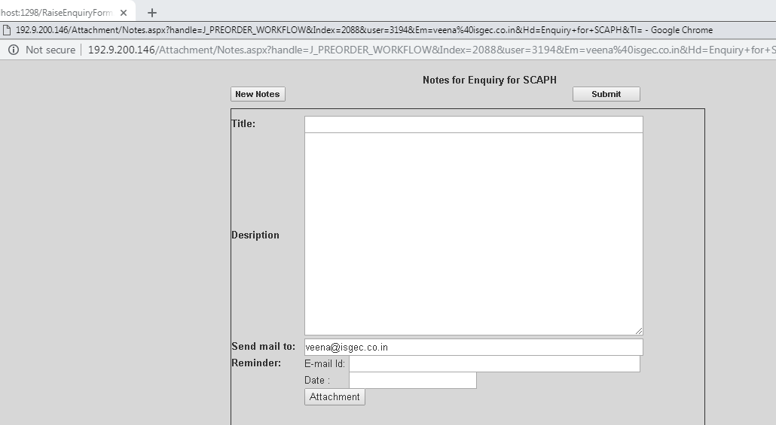
Submit Mail
Enter Details

- In the screen that open up Click Ok and this will appear as notes as shown below and an Email Alert is send to Vendor.
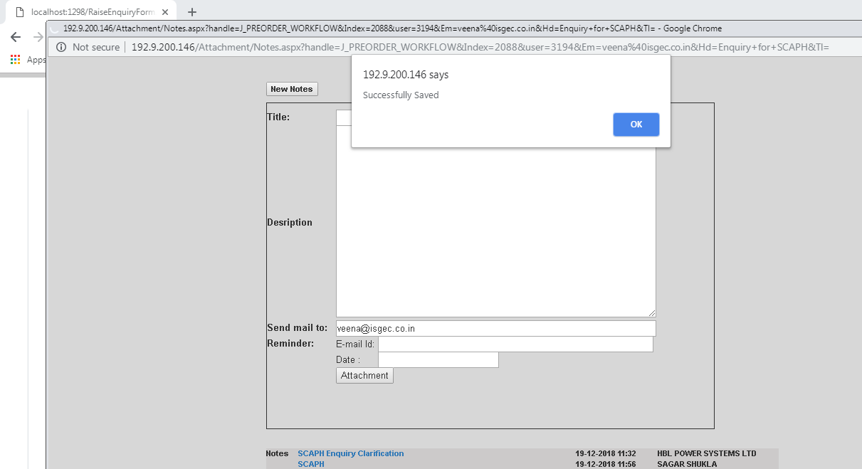
Latest Note
Click OK

- Vendor has to click on the Link provided in the First mail to view the Notes, this Process will continue back and Forth.
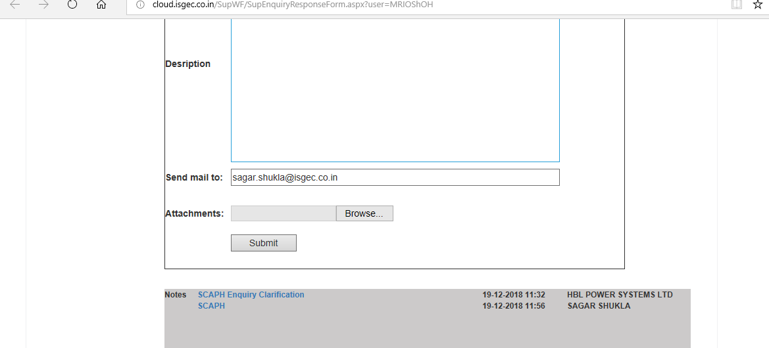
Revert Note from Buyer

